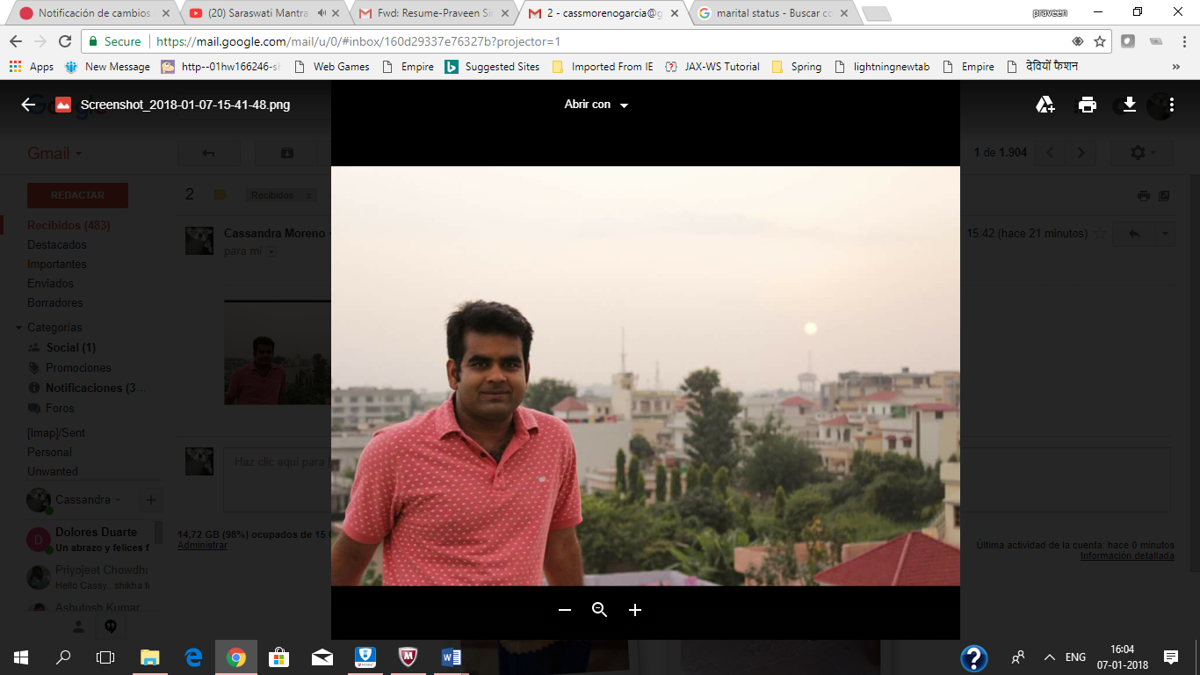

PRAVEEN SINGH RAWAT

Email: [rawatpraveen1000@gmail.com](mailto:rawatpraveen1000@gmail.com)

Contact: (442) 771 2962   
Date of Birth: 04th Dec 1988

Nationality: Indian

Marital Status: Married to a Mexican citizen.

Languages: English, Spanish,Garhwali, Hindi

Education:

* Bachelor of Technology in Computer Engineering- 2008- 2011
* Bachelor of Science- 2005- 2008

**SUMMARY**

* 6+ years of experience in enterprise level IVR application development using open source languages like Java, vxml, javascript etc. with strong knowledge in the IVR components.
* Experience in Avaya and Genesys based IVR development. Developed more than 15 enterprise IVR in Avaya and Genesys platform.
* Experience in IVR environment (MCP, ASR, TTS and MRCP).
* In depth knowledge of the IVR integration with Avaya IC.
* In depth knowledge of the IVR integration with Cisco (with sip).
* Experience in Agile methodology for continuous delivery of various projects in small sprints.
* Experience in end to end delivery of the project (Requirement gathering, Technical design, technical lead/development, QA support, UAT support and production deployment).
* Experience in the ITIL processes and critical production support.
* Experience in Incident management, Change Request management using BMC Remedy.
* 3L Support for the double mission critical applications.
* Experience with Continuous delivery and Continuous integration which allows to reduce risks for a project and maintain the quality of the code using products such as GIT, Gradle, ANT, Maven, Subversion, SonarQube.
* Migration of the application to DevOps.

**TECHNICAL SKILLS**

|  |  |
| --- | --- |
| **Languages** | Java SE, JEE 5, vxml2.0, Javascript, AJAX, JSP, HTML, JPA, XML,  Spring Framework (Core, JDBC Template, WS, Batch), SOAP and rest and soap based Web Services. |
| **Databases** | MySQL, Oracle, SQL server. |
| **IDEs** | Eclipse IDE, IBM Rational Application Developer. |
| **Tools** | SOAP (JAX-WS), REST (JSON), IBM Websphere Application Server 6.1, Websphere Application server 8.5, Apache, Tomcat Server, SQL Developer, Tortoise SVN, Unix, Windows, SonarQube, Bamboo, Stash, DevOps concepts. |
| **Certification** | Oracle certified Java Programmer 5  Oracle Certified Java Platform EE 5 Web Component Developer.  Oracle Certified Java Web Services developer  IBM certified Rational Application Developer |

**PROFESSIONAL SUMMARY**

1. Tata Consultancy Services / Project: Walgreens Co. / Continuous Service Improvement

(Retail and TFN IVR)

***Position: Technical Lead***

Feb’ 16 – Dec’ 17

***Responsibilities:***

* Requirement gathering for agile sprints for various IVR applications based on Genesys and Avaya Platform.
* Validation of the VUI (Voice User Interface) and grammars and prompts provided by Voxgen.
* Estimation of the sprint.
* Daily scrum meeting with business team on the progress of the sprint.
* Development and coordination with the offshore development team on the project.
* Coordination with multi-disciplinary teams with administrative and technical skills.
* SLA Management
* On Time Delivery Metrics.
* QA environment set and full QA support.
* UAT environment set up and full UAT support.
* Full responsibility of the production deployment and DAR creation and standard ITIL process for code deployment in a clustered environment.

**Environment:**Java, J2EE, Spring, WebSphere Application Developer 8.5, Tomcat 5.5, VXML 2.0

1. Tata Consultancy Services / Project: Walgreens Co. / NextGenEComIVR

(Toll Free Number Avaya based IVR)

***Position: Developer and Tech lead***

Jul’15 –Jan’16

***Responsibilities:***

* Architecture development using Spring and call flow developer using vxml 2.0.
* Requirement gathering and validation of the VUI (Voice User Interface) and grammars and prompts provided by Voxgen.
* Creation of the QA, UAT environment.
* Creation of the WAS 8.5 clustered production environment in 2 datacenters.
* Tuning of the WAS 8.5 application server w.r.t. to session setting and pure app configuration.
* Production deployment of the application and 3L support if any issues get escalated from the RunOps team.

**Environment:** Java, J2EE, Spring,WebSphere Application Developer 8.5, VXML 2.0, Avaya Voice Portal 4.1.

1. Tata Consultancy Services / Project: Walgreens Co./ NextGenRCEIVR

(Retail Store based Centralized IVR on Genesys Platform)

Sep’14 – Jun’15

***Position: Technical Lead / Java and VXML developer***

***Responsibilities:***

* Call flow design with vxml 2.0 and backend with bOunce framework (Build on top of Spring framework)
* Web Services integration with multiple external interfaces.
* Responsible for the 2 way SSL configuration set up and coordination with multiple teams regarding the same.
* QA support.
* Follow ITIL processes and production deployment of the code.
* Analyze any production issues reported by the RunOps team.

**Environment:**Java, J2EE, Spring,WebSphere Application Developer 8.5, VXML 2.0, Genesys Voice Portal 8.5

1. Tata Consultancy Services / Project: Walgreens Co./ WAS Migration( WAS 6.1 application migration to WAS 8.5)

(Retail IVR)

Oct’13 – Aug’14

***Position: Technical Lead***

***Responsibilities:***

* Code migration with WAS8.5
* QA,UAT and production environment set up for WAS8.5 pure app servers.
* Full QA support.
* Production deployment and monitoring of the applications till the environment is stable.
* Reporting of the applications based on the monitoring tools, Tivoli, SMARTS, Empirix.

**Environment:** Java, J2EE, Spring,WebSphere Application Developer 8.5, VXML 2.0, Genesys Voice Portal 8.5

1. *Tata Consultancy Services / Project: Walgreens Co./ Walgreens Health Care IVR*

(Toll Free Number Avaya Based IVR)

***Position: Java Developer*** Mar’13 – Sep’13

***Responsibilities***

* Requirement gathering.
* Call Flow designing in VXML and bOnce Java framework.
* Integration with Avaya IC call flows.
* Integration with Avaya Voice Portal 4.1
* Reporting of the call distribution based on the call flow.
* Architecture designing of the application.
* POC for the integration of the IVR and the Avaya IC.

**Environment:**Java, J2EE, Spring,Tomcat 5.5, VXML 2.0,Avaya Voice Portal 4.1, Avaya IC

1. *Tata Consultancy Services / Project: Walgreens Co. / NextGenDTMF IVR*

(Retail IVR)

***Position: Developer***

Mar’12 - Feb’13

***Responsibilities***

* Development of VXML call flows in vxml 2.0 as the front end and bOunce(proprietary Java framework on top on Spring) as the back end.
* Development of JAX-WS based web services for feeding the daily feeds to the IVR.
* Development of the Caching framework for the IVR application and its web based maintenance.

**Environment:** Oracle Database, bOunce(on top of Springframework), Java, IBM Websphere Application Server 6.1, Java Web services.

1. *Tata Consultancy Services / Project: Walgreens Co. / Select IVR*

(J2EE Web application)

***Position: Developer***

Sep’11 - Feb’12

***Responsibilities***

* Development of Servlets and JSPs for the wrapper application for the numerous IVR application.
* Integration with the various IVR application.
* Development of the Caching framework for this web application.

**Environment:** Oracle Database, J2EE, IBM Websphere Application Server 6.1, Ajax,JSP.